**SPRINT4**

|  |  |
| --- | --- |
| Date | 16November 2022 |
| TeamID | PNT2022TMID17177 |
| ProjectName | Project – Smart Farmer-IoT Enabled smartFarmingApplication |

**CONFIGURATIONOFNODE-REDTOSENDCOMMANDSTOIBMCLOUD**

Hereweaddtwobuttons inUI1->formotoron

2->formotoroff

Weusedafunctionnodetoanalysesthedatareceivedandassigncommandtoeachnumber.

The Java script code for the analyses is:if(msg.payload===1)msg.payload={"command”: “ON"};else if(msg.payload===0)msg.payload={"command”:“OFF"};

# AdjustingUserInterface

InordertodisplaytheparsedJSONdataaNode-Reddashboardiscreated

Here we are using Gauges, text and button nodes to display in the UI andhelps tomonitortheparametersandcontrolthefarmequipment.

Belowimageswestartedtocreatetheflow1

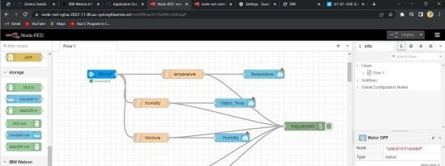

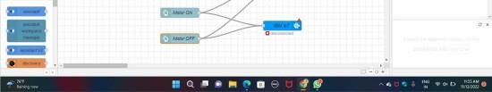

**COMPLETEPROGRAMFLOW:**

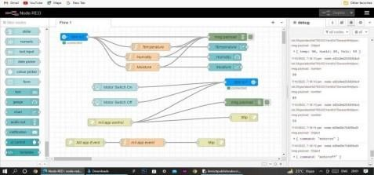

# SCREENSHOTS:

